Combined photoionization and avalanche ionization rates;
$\frac{{∂n}_{e}}{∂t}=W_{PI}\left(I\left(t\right)\right)+W_{AV}\left(I\left(t\right)n_{e}(t)\right)$ (2)
where $W_{PI}$ and $W_{AV}$ are the photoionization and avalanche ionization rates, respectively, $n_{e}$ is the free electron density, and $I\left(t\right)$ is the instantaneous laser intensity. $W_{PI}$ is expressed as
$W_{PI}=\frac{4ω}{9π}{\left(\frac{ωm_{e}^{r}}{ℏγ_{1}}\right)}^{1.5}Q\left(γ,\tilde{x}\right)×exp\left[-π×\left\lfloor \tilde{x}+1\right\rfloor \frac{K\left(γ_{1}\right)-M\left(γ_{1}\right)}{M\left(γ_{2}\right)}\right]$ (3)
where $Q\left(γ,\tilde{x}\right)=\sqrt{π/{\left(2K\left(γ_{2}\right)\right)}}\sum_{j=0}^{∞}{\left[exp\left(-πj\frac{K\left(γ_{1}\right)-M\left(γ_{1}\right)}{M\left(γ_{2}\right)}\right)×∅\left(π\sqrt{\frac{\left\lfloor \tilde{x}+1\right\rfloor -\tilde{x}+j}{2K\left(γ_{2}\right)M\left(γ_{2}\right)}}\right)\right]}$,
$γ_{1}=γ/{\sqrt{1+γ^{2}}}$, $γ_{2}=1/{\sqrt{1+γ^{2}}}$, $∅\left(x\right)=e^{{-x}^{2}}\int_{0}^{x}{e^{t^{2}}dt}$, $\tilde{x}={2E_{g}M\left(γ_{2}\right)}/{\left(πℏωγ_{1}\right)}$.
Here, $K$ and $M$ are elliptic integrals of the first and second kind, respectively, $m_{e}^{r}$ is the electron reduced mass, $\tilde{x}$ is the effective bandgap, $∅\left(x\right)$is the Dawson function, and $ℏ$ is the reduced Planck’s constant.
The impact ionization is described by the Drude model and is expressed as
$W_{AV}=\frac{σ}{E_{g}}I(t)$ (4)
where $σ$ is the single-photon absorption cross-section
$σ=\frac{e^{2}}{{cε}_{0}m_{e}n_{0}}\frac{τ_{c}}{1+{ω^{2}τ}_{C}^{2}}$ (5)
Here, $τ_{c}$ is the collision time given as
$τ_{c}=\frac{16πε_{0}^{2}\sqrt{m{(0.1E_{g})}^{3}}}{\sqrt{2}e^{4}n_{e}(t)}$ (6)
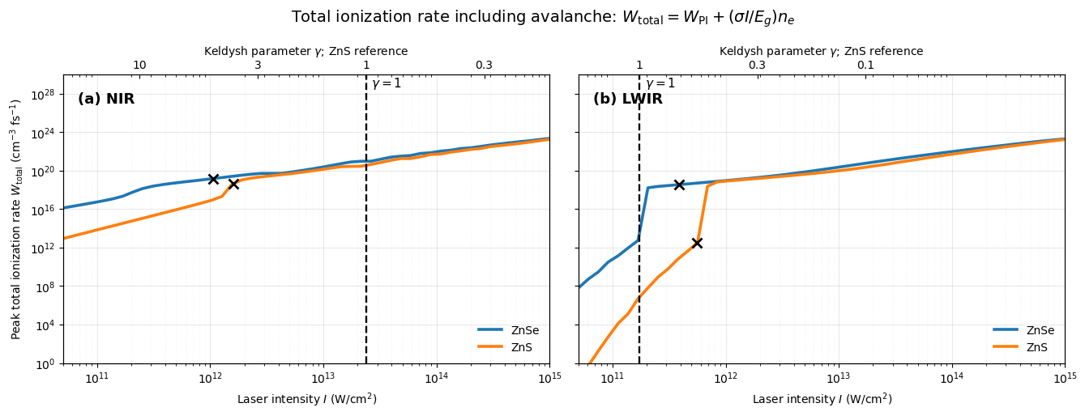
================ Density-growth summary ================

Case | lambda(um) | I0(W/cm2) | n_photo(cm-3) | n_av_added(cm-3) | n_total(cm-3)
ZnSe_NIR | 0.8 | 1.0522e+12 | 4.2925e+20 | 8.3139e+20 | 1.2606e+21
ZnS_NIR | 0.8 | 1.5970e+12 | 1.7118e+19 | 2.5055e+20 | 2.6767e+20
ZnSe_LWIR | 9.2 | 3.8987e+11 | 1.1290e+18 | 5.6853e+21 | 5.6864e+21
ZnS_LWIR | 9.2 | 5.5897e+11 | 1.5994e+15 | 2.7382e+14 | 1.8733e+15

Additional plots
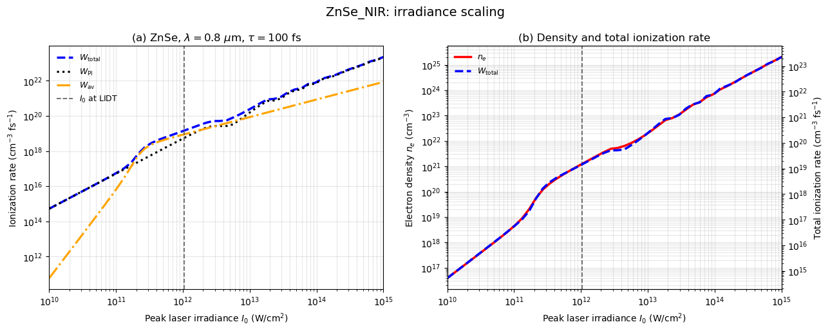
- NIR
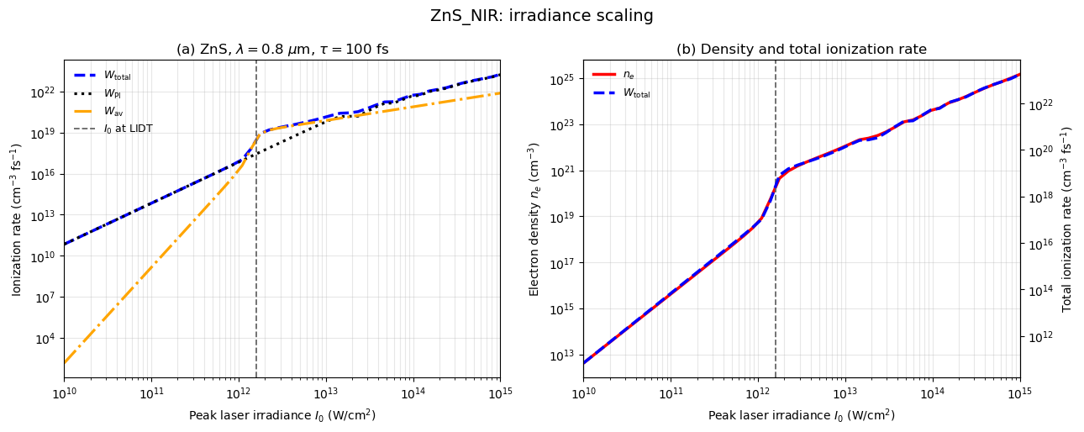

Dependence of peak ionization rates and electron density on the laser intensity.
At lower laser intensities, photoionization ($W_{PI}$) dominates, and the electron density is not enough for avalanche (time for avalanche (Eq. 6, collision time reduces as 1/$n_{e}$) exceeds the pulse duration). The absorption cross-section increases with the reduction of collision time (Eq. 5). Thus, the impact ionization rate ($W_{AV}$) shows linear dependence with laser intensity (Eq. 4). The total ionization rate ($W_{total}$) coincides with photoionization.
At higher intensities, the collision time gets shorter, and the absorption cross-section reaches a maximum at 1/$τ_{c}$=$ω$. The $W_{AV}$ dependence on laser intensities becomes nonlinear, and there is a strong feedback between $n_{e}$ and $W_{AV}$ which becomes explosive at 1/$τ_{c}$=$ω$, resulting in step-wise increase in $n_{e}$and the total ionization rate ($W_{total}$). The step-wise increase also characterizes a transition from a photoionization-dominated mechanism to an impact ionization-dominated mechanism taking place at some threshold intensity $I_{th}$, when $W_{PI}$ ($I_{th}$)=$W_{AV}$ ($I_{th}$).

- LWIR

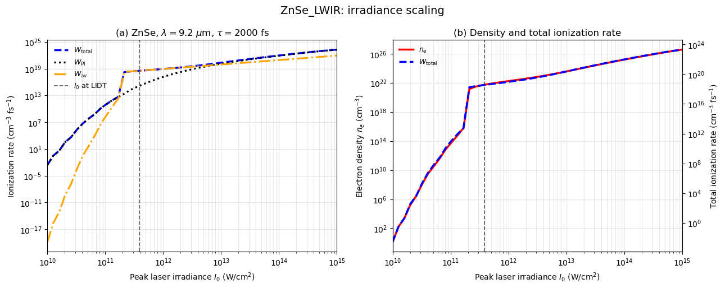

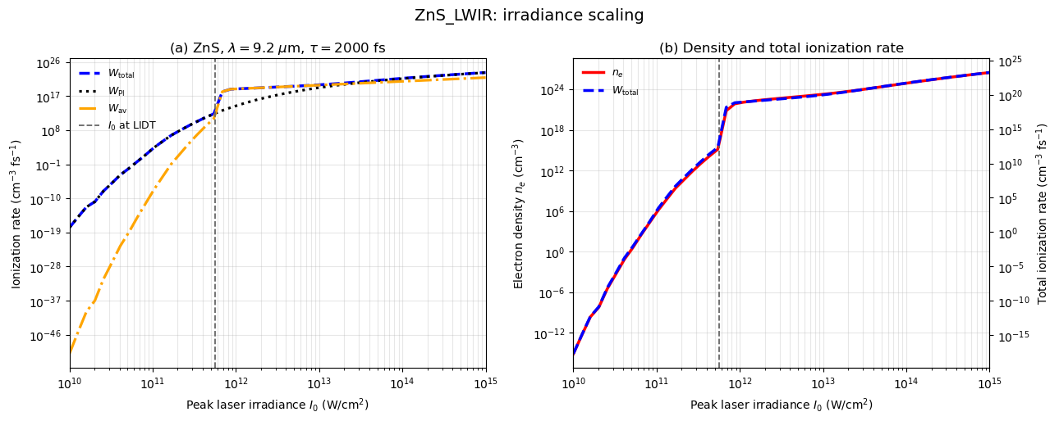
At lower intensities, photoionization dominates.
At higher intensities, the stepwise increase in the ionization rate and electron density appears more rapid than in the NIR case, i.e., the step occurs over a smaller range of intensities.
Can the threshold intensities at the initiation of step-wise increase of electron densities be associated with LIDT?

- NIR and LWIR comparison
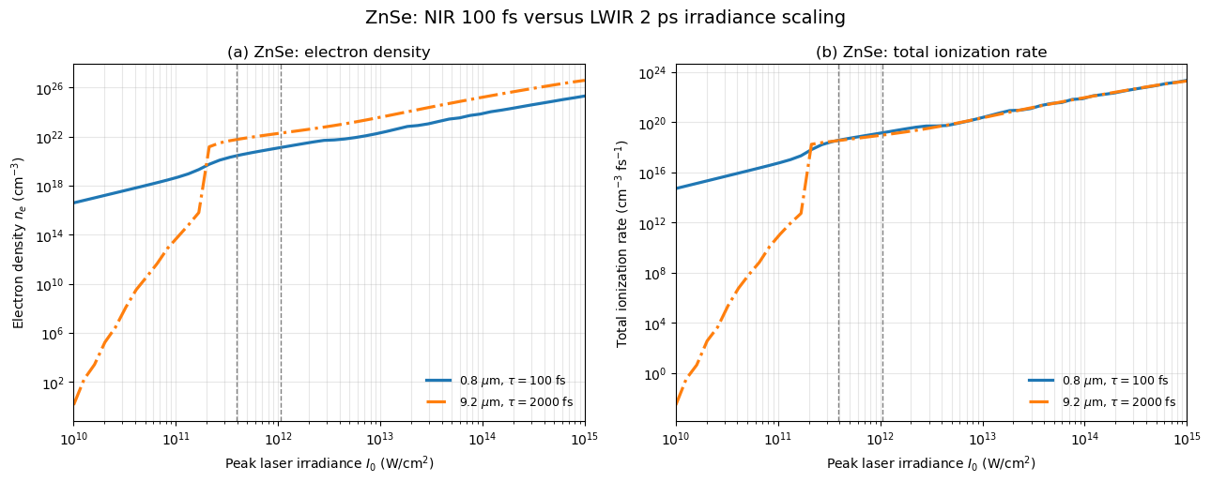

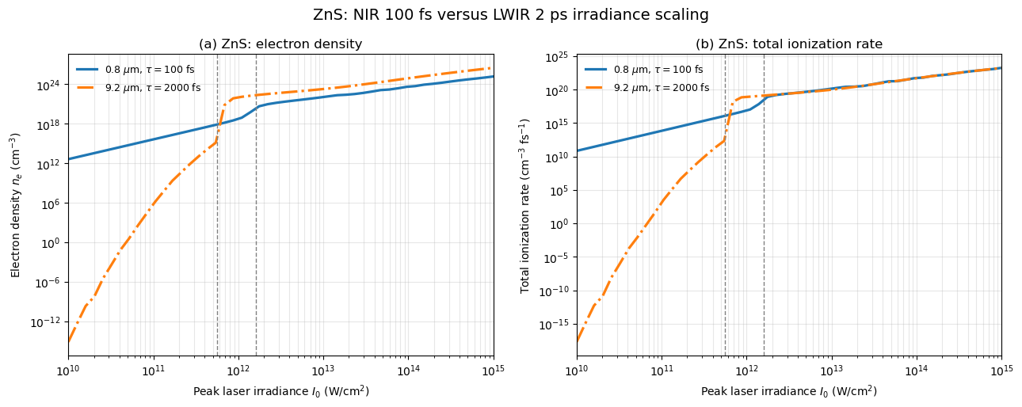
The vertical dashed lines correspond to the intensities at the measured LIDTs: NIR (right line), LWIR (left line).

